BREAST CANCER PREDICTION

Problem statement:
Suggest the required diagnosis for curing breast cancer.
Dataset size:
(569, 33)
It contains 569 rows and 33 columns.
Feature names and datatypes:
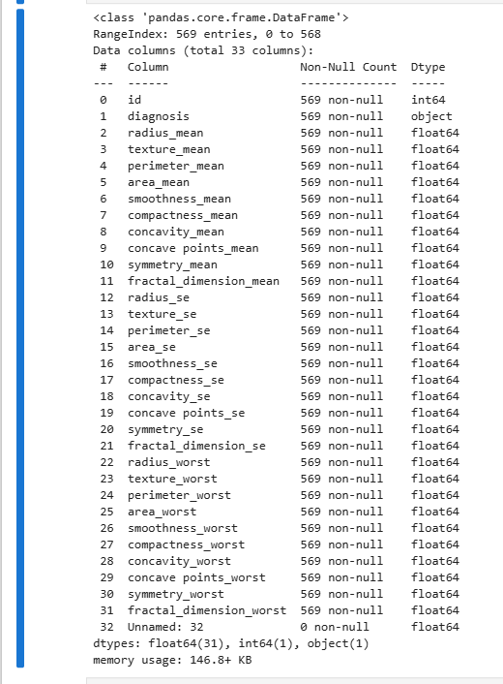

Null values:
Unnamed: 32 have no records.
Outliers:
Every column is having outliers.
Load the dataset:
df=pd. read_ csv('data.csv')

Data cleaning process:
1. Dropped Unnamed: 32 column and id column.
2.Outlier treatment.
Label encoding for target:
Using label encoder encoded Diagnosis from object to num. (0 and 1)
Feature selection:
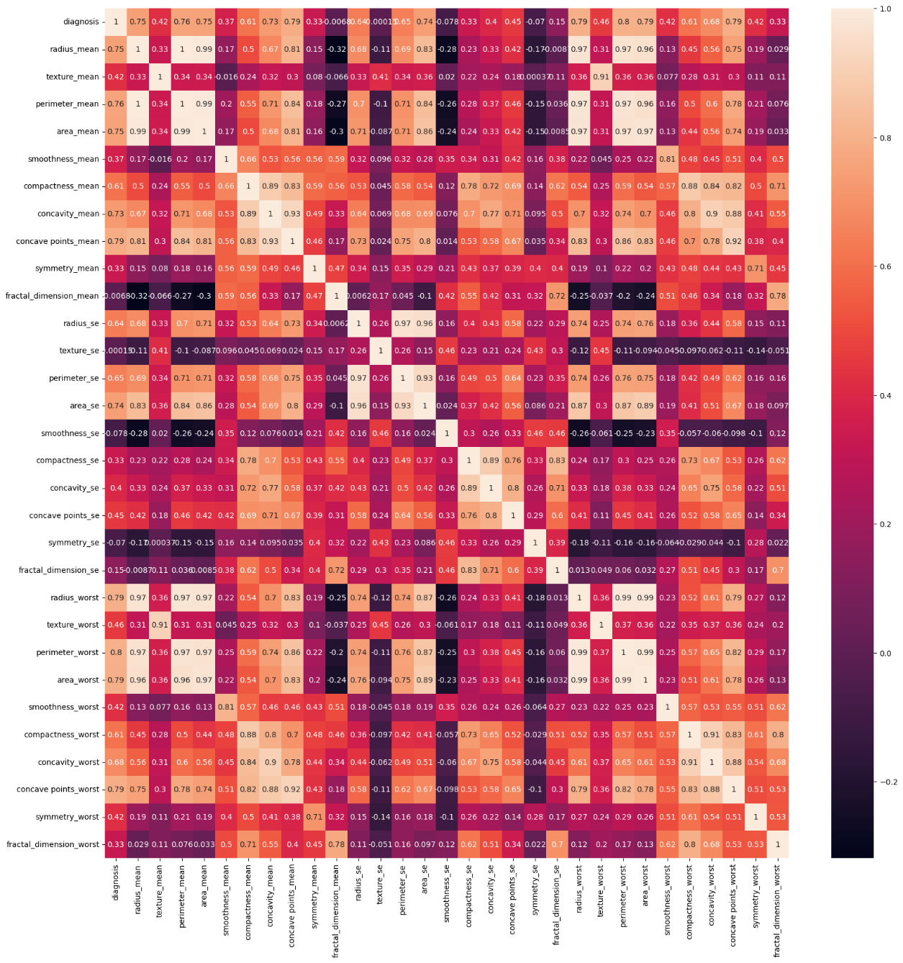
1.performed corr() for df and heatmap for that.

2. Final features selected are
X=df.drop(['diagnosis','texture_worst','concave points_se','smoothness_worst','texture_mean','symmetry_worst','concavity_se','smoothness_mean','symmetry_mean','compactness_se','fractal_dimension_worst','fractal_dimension_se','smoothness_se','symmetry_se','fractal_dimension_mean','texture_se'], axis=1)
y=df ['diagnosis ']
Data transformation:
Applied StandardScaler () on X.
Data partition:
x_train, x_test, y_train, y_test= train_test_split (x, y, test_size=0.3, random_state=42)
Train size: 70
Test size: 30
Model Selection:
As it is classification I performed all the models, each model evaluation is as follows,
Logistic Regression
Train accuracy 0.96
Train accuracy 0.95
cross validation mean score: 0.95
roc: 0.99

SVM
Training Accuracy: 0.9597989949748744
Testing Accuracy: 0.9473684210526315
cross validation mean score: 0.9437975469647568
roc: 0.99

Decision Tree
Train accuracy 0.96
Train accuracy 0.94
cross validation mean score: 0.9244837758112094
roc: 0.96

Bagging
Train accuracy 1.0
Train accuracy 0.96
cross validation mean score: 0.9385343890700202
roc: 0.99

Random Forest
Train accuracy 0.99
Train accuracy 0.96
cross validation mean score: 0.9455519329296692
roc: 0.99

AdaBoost
Train accuracy 0.99
Train accuracy 0.96
cross validation mean score: 0.9455519329296692
roc: 0.99

Gradient Boosting
Train accuracy 1.0
Train accuracy 0.95
cross validation mean score: 0.9490607048594939
roc: 0.99

XGBoost
Train accuracy 1.0
Train accuracy 0.95
cross validation mean score: 0.9402732494954199
roc: 0.99

LightGBM

